Web Developer Test Questions

1. Please state 3 advantages and disadvantages of using CMS
   1. Advantages
      1. User friendly layout as they do not need to posses much technical skills when developing website/interface. Usually utilise drag and drop for its’ elements.
      2. CMSs are very flexible as they have access to a wide range of templates and can be used to create a variety of websites ranging from blogs to e-commerce sites.
      3. Some CMS systems allow collaboration of content between multiple users and roles which allows the different team members to work on the sites’ content, publishing, and editing.
   2. Disadvantages
      1. Advanced customization is limited compared to a fully custom-coded website. The customization is tied to how much the theme developer allows.
      2. CMS sites may face performance issues which may affect the SEO rankings. Reason being, CMS relies on plugins, themes, and extensions which may slow down the loading times – thus affecting user experience.
      3. Using a CMS may be pricey especially for SMEs or individuals on a tight budget. The mandatory costs include licenses, hosting plans as well as additional costs of plugins, widgets and extensions.
2. CSS Test - Every user on your website has an image avatar that is displayed when they post a comment. You want to style these images differently from other images on your site. Add a CSS class named avatar that fulfils the following requirements:

* The avatar's border is rounded, so that it appears as a circle.
* The avatar's width and height are both 150px.
* The avatar has a solid border, has a width of 2px, and be coloured grey.

<!DOCTYPE html>

<html>

<head>

<meta charset="utf-8">

<title>Avatar</title>

<style>

/* Write your CSS solution here (do not edit the surrounding HTML) */

.avatar {

border-radius:50%;

height: 150px;

width: 150px;

border: 2

</style>

</head>

<body>

<img class="avatar" src="https://goo.gl/khGCrk" alt="avatar" />

</body>

</html>

1. Please create a simple API; You are require to send an http post request to a page and get the result back
   1. Below is a simple html form, please create the action page PHP file and get the user’s submitted data and display a simple welcome message.

“Hello [fname] , we’ve received your emails from [email] !“

<form action="/action_page.php">

<label for="name">Name:</label>

<input type="text" id="name" name="name" value=" ">

<label for="email">Email:</label>

<input type="text" id="email" name="email" value=" ">

<input type="submit" value="Submit">

</form> >

**Steps:**  
1. Change the html file form containing the form to php.

2. Add method =”get” into the form action inside the form file.

*<form action="/action_page.php" method="get">*

3. Create new php file and enter snipper below:

<?php

$name = $_GET["name"];

$email = $_GET["email"];

echo "Hello " .$name. ", we've have received your emails from " . $email . "!";

?>

1. Please create a responsive table with data below;

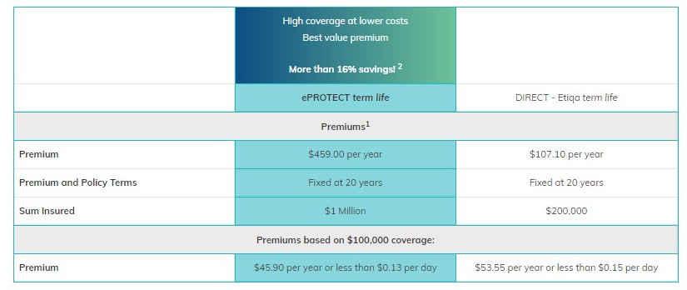

Code:

<!DOCTYPE html>

<html>

<head>

<meta name="viewport" content="width=device-width, initial-scale=1">

<style>

table {

  border-collapse: collapse;

  border-spacing: 0;

  width: 100%;

  border: 2px solid #ddd;

}

th, td {

  text-align: center;

  padding: 8px;

  border-top: 2px solid #ddd;

  border-bottom: 2px solid #ddd;

}

td:nth-child(even){

    background-color: rgb(131, 211, 218);

    border: 2px solid rgb(124, 200, 206)}

.grey-row{

    background-color: #f2f2f2 !important ;

    border: none !important;

    font-weight: bold;

}

.grad {

  background-image: linear-gradient(to right, rgb(11, 83, 132) , rgb(104, 189, 150));

  color: white;

  font-weight: bold;

}

</style>

</head>

<body>

<h2>Responsive Table</h2>

<p> :D </p>

<div style="overflow-x:auto;">

  <table >

    <tr>

        <td></td>

      <td class="grad">

        High Coverage at lower costs<br>

        Best Value Premium<br><br>

        More than 16% Savings!<sup>2</sup>

        <td></td>

    </td>

    </tr>

    <tr>

      <td > </td>

      <td>ePROTECT term life</td>

      <td>DIRECT - Etiqa term life</td>

    </tr>

    <tr class="grey-row"><td> </td>

        <td class="grey-row">Premiums<sup>1</sup></td>

        <td> </td>

      </tr>

    <tr>

      <td >Premium</td>

      <td>$459.00 per year</td>

      <td>$107.10 per year</td>

    </tr>

    <tr>

        <td >Premium and Policy Terms</td>

        <td>Fixed at 20 years</td>

        <td>Fixed at 20 years</td>

      </tr>

      <tr>

        <td >Sum Insured</td>

        <td>$1 Million</td>

        <td>$200,000</td>

      </tr>

      <tr class="grey-row">

      <td> </td>

        <td  class="grey-row">Premiums based on $100,000 coverage:</td>

        <td> </td>

    </tr>

      <tr>

        <td > Premium</td>

        <td>$45.90 per year or less than $0.13 per day</td>

        <td> $53.55 per year or less than $0.15 per day</td>

      </tr>

  </table>

</div>

</body>

</html>

1. In your opinion what are the necessary action to optimise a website in order to improve a website performance, please provide 5 solutions and elaborate your answer.
   1. Optimize the images. Images are usually the ‘heaviest’ part of the website thus taking a toll on the sites’ performance. One way to counter it is via lossless compressions such as PNGs or using lossless compressions such as JPEG.
   2. Too many HTTP requests to load the site. The more request done via loading of external resources, fonts, scripts the slower it gets. By minimizing these, it will speed up load time by reducing requests.
   3. Long loading times since a lot of resources has to be generated. This can be countered via caching to store some HTML content so that it does not need to be generated per request. This can be done via server-side or browser caching.
   4. On the topic of loading, using a lightweight theme or framework may help in loading times. These light themes are designed to lessen HTTP requests and optimize the loading of the resources.
   5. Sometimes just updating the website’s software to the latest version can help. The developers usually release updates on performance and security regularly and these may help in improving the sites’ performance.